THE UNIVERSITY OF AZAD JAMMU & KASHMIR
Department of Software Engineering
LAB 04 — STUDENT CASE STUDY
UML Sequence Diagram: ATM Cash Withdrawal System
Student Name: Tanzeela rehman | Roll no : 2025-SE-36
Course: Software Design and Architecture | Semester: 3rd

1. Objective
To construct a UML sequence diagram showing the participants, lifelines, chronological messages, replies, and alternative outcomes involved in withdrawing PKR 5,000 from an ATM.

2. Scenario
A customer inserts an ATM card, enters a PIN, and requests to withdraw PKR 5,000. The ATM sends the card information and PIN to the BankSystem for validation. After the PIN is validated, the BankSystem checks the customer's Account. If sufficient funds are available, the account is debited and the ATM dispenses the cash. If the PIN is invalid or the balance is insufficient, the ATM displays an appropriate message and does not dispense cash.

3. System Participants
Participant | Responsibility
Customer | Starts the transaction, inserts the card, enters the PIN, and requests withdrawal.
ATM | Receives customer input, communicates with the BankSystem, displays messages, and dispenses cash after approval.
BankSystem | Validates the PIN, checks withdrawal authorization, and communicates with the Account.
Account | Provides balance information and debits PKR 5,000 when permitted.

4. Sequence of Messages
The following messages are arranged from top to bottom in chronological order:
No. | Sender → Receiver | Message
1 | Customer → ATM | Insert ATM card
2 | Customer → ATM | Enter PIN
3 | ATM → BankSystem | Send card information and PIN for validation
4 | BankSystem → ATM | Return PIN validation result
5 | Customer → ATM | Request withdrawal of PKR 5,000 (only after valid PIN)
6 | ATM → BankSystem | Forward withdrawal request
7 | BankSystem → Account | Check whether at least PKR 5,000 is available
8 | Account → BankSystem | Return balance status
9 | BankSystem → Account | Debit PKR 5,000 (sufficient-funds branch only)
10 | Account → BankSystem | Send debit confirmation
11 | BankSystem → ATM | Send withdrawal approval
12 | ATM → Customer | Dispense PKR 5,000
13 | ATM → Customer | Display success message

5. Alternative Conditions (alt Combined Fragment)

A. [Valid PIN]
The BankSystem confirms that the PIN is valid. The customer may then request PKR 5,000. The BankSystem asks the Account to check the available balance.

B. [Invalid PIN]
The BankSystem returns an invalid-PIN result. The ATM displays an invalid-PIN message. The withdrawal process stops; no withdrawal request is processed and no cash is dispensed.

C. [Sufficient funds]
The Account confirms that at least PKR 5,000 is available. The BankSystem requests the Account to debit PKR 5,000 and waits for confirmation. After confirmation, the BankSystem approves the withdrawal. The ATM dispenses PKR 5,000 and displays a success message.

D. [Insufficient funds]
The Account reports that the available balance is less than PKR 5,000. The BankSystem refuses the transaction and informs the ATM. The ATM displays an insufficient-funds message. No debit takes place and no cash is dispensed.

6. UML SEQUENCE DIAGRAM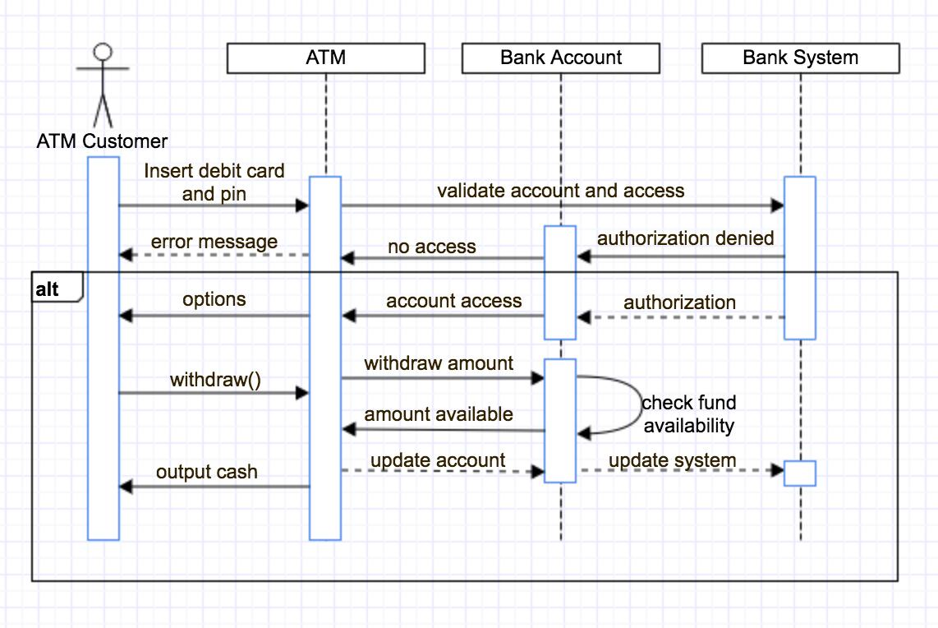

8. Answers to Design Questions
Who initiates the first message? The Customer initiates the transaction by inserting the ATM card.
Who validates the PIN? The BankSystem validates the PIN.
Who knows whether enough money is available? The Account provides the balance-related information.
Which message must occur before cash dispensing? The ATM must receive withdrawal approval from the BankSystem after the debit is confirmed.
What happens if funds are insufficient? The ATM displays an insufficient-funds message. No debit or cash dispensing occurs.
What changes if the customer enters the wrong PIN? The invalid-PIN branch is followed, an error message is displayed, and withdrawal processing does not continue.
Modelling Constraints and Assumptions
The withdrawal amount is fixed at PKR 5,000 throughout this case study.
The ATM is assumed to have sufficient physical cash and the network is assumed to be available; no cash - stock or
connectivity branches are modelled.
The diagram focuses on message ordering. Activation bars and low - level implementation details are optional and
are not required.
No class attributes, database tables, or data- flow arrows are included because this is a sequence diagram.
Assumption: after the BankSystem receives debit confirmation, it sends approval to the ATM; the ATM dispenses
cash only after receiving that approval.
Assumption: invalid- P IN handling is shown as an alternative outcome of PIN validation and terminates the
withdrawal flow.
Design Note (100 –150 Words)
The sequence begins when the Customer inserts a card and enters a PIN. The ATM sends the card information and
PIN to the BankSystem for validation. Withdrawal processing is allowed only when the PIN is valid. The ATM then
forwards a request for PKR 5,000, and the BankSystem asks the Account to check the available balance. The alt
fragment separates sufficient - funds and insufficient - funds outcomes. When funds are sufficient, the BankSystem
requests a debit and waits for confirmation before sending approval t o the ATM. Only then does the ATM dispense
cash and display success. If funds are insufficient, the ATM displays an appropriate message and neither debit nor
cash dispensing occurs. If the PIN is invalid, the ATM displays an error and stops the withdrawal flow. The ATM is
assumed to have cash and network service.

